Homework 5 Finite-volume method for unstructured grids

Yanjun Zhang [yanjunzh@kth.se](mailto:yanjunzh@kth.se) 20/02/2023

# Task 1

## a)

choose



So the analytical values are



For the analytical result plots, they have same color, which is equal to 0 for bellowing figures.

**Square geometry with quadrilateral elements:**

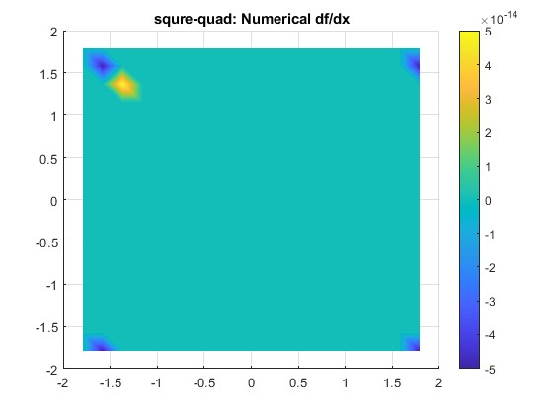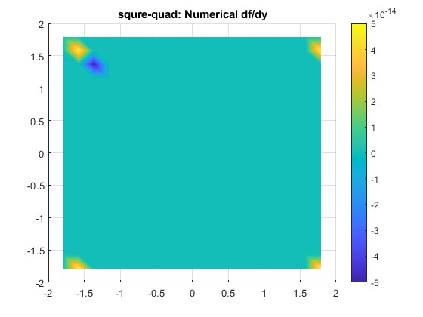

Figure Square geometry with quadrilateral elements

As shown in figure 1, the numerical value for both should be 0, while in the four corners, there are some errors. So for the square geometry with quardrilaeral elements, the error mainly from the corners.

**Square geometry with uniform triangular elements:**

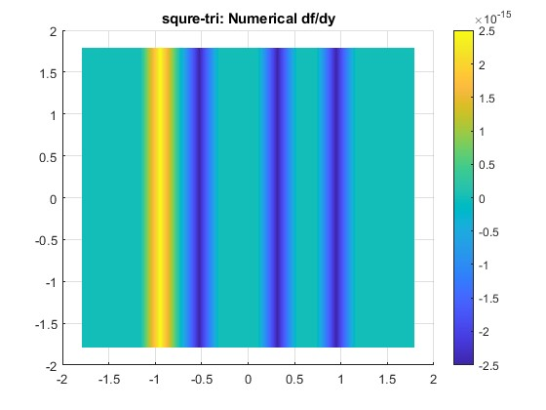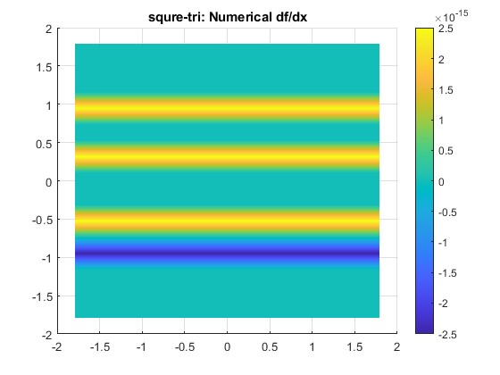

Figure Square geometry with uniform triangular elements

As shown in figure 2, it seems have many errors in both derivatives of x and y directions. So it not an accurate element to choose.

**Triangular geometry with uniform triangular element:**

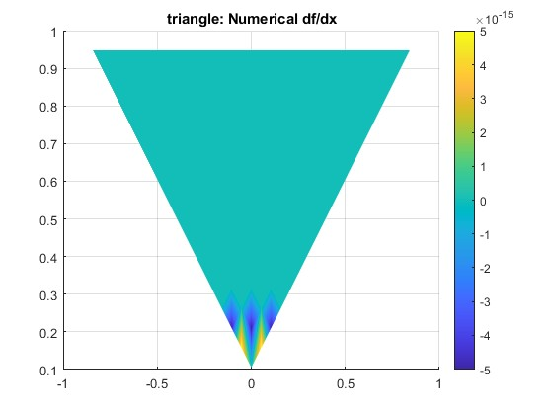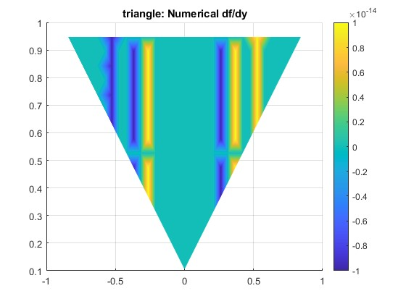

Figure Triangular geometry with uniform triangular element

As shown in figure 3, the x derivative has small error while y direction has large error. So for triangular geometry, the uniform triangular element is not good.

**Triangular geometry with non-uniform triangular elements:**

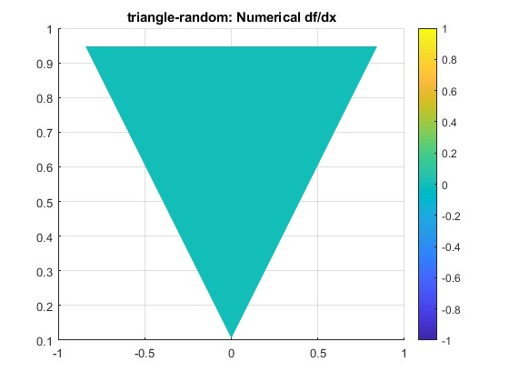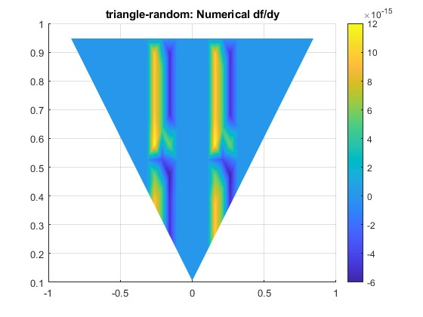

Figure Triangular geometry with non-uniform triangular elements

As shown in figure 4, x direction derivative does not have any error while y direction has some error, but still better than uniform triangular elements.

## b)



**Square geometry with quadrilateral elements:**

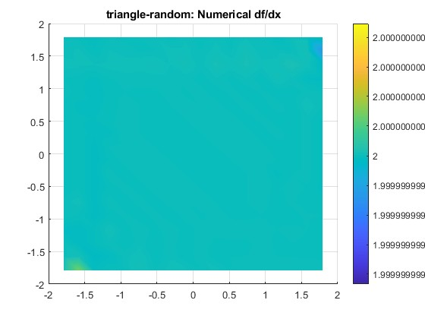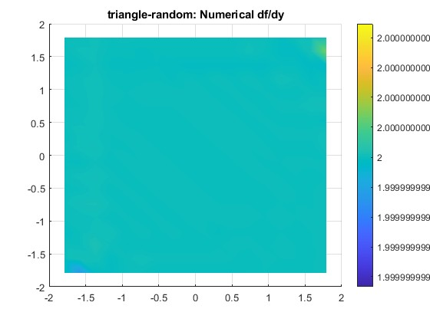

Figure Square geometry with quadrilateral elements

As shown in figure 5, the numerical value for both should be 2, while in the four corners, there are some errors. So for the square geometry with quadrilateral elements, the error mainly from the corners.

**Square geometry with uniform triangular elements:**

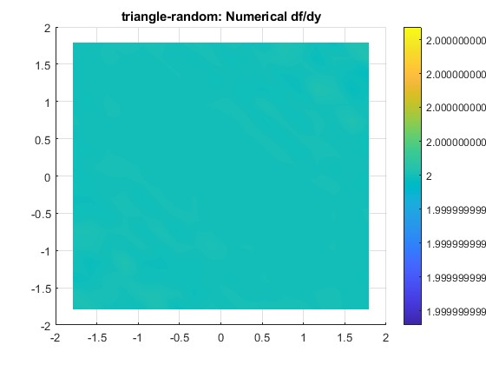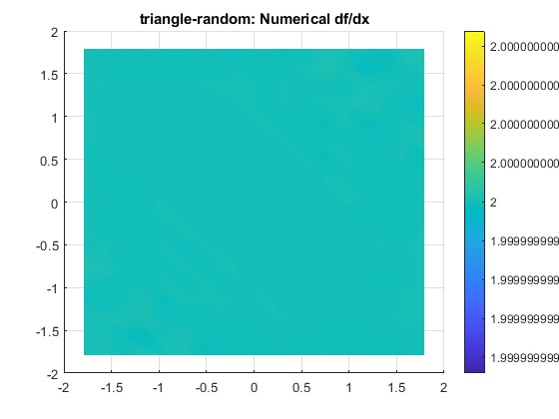

Figure Square geometry with uniform triangular elements

As shown in figure 6, it seems this case does not have error, so it is good mesh method.

**Triangular geometry with uniform triangular element:**

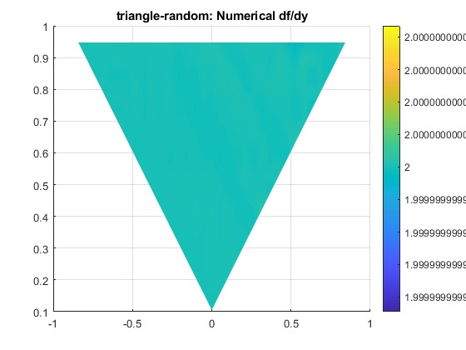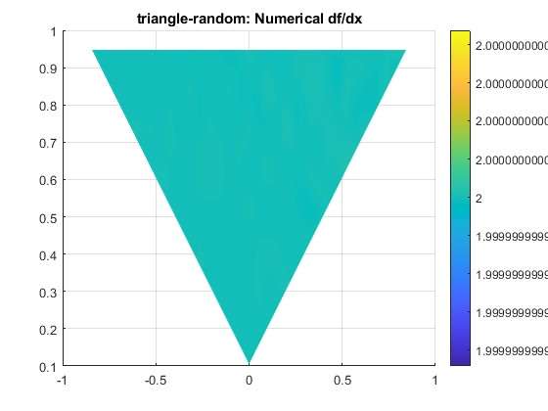

Figure Triangular geometry with uniform triangular element

As shown in figure 7, nearly no error exist, so this kind of geometry also has good performance.

**Triangular geometry with non-uniform triangular elements:**

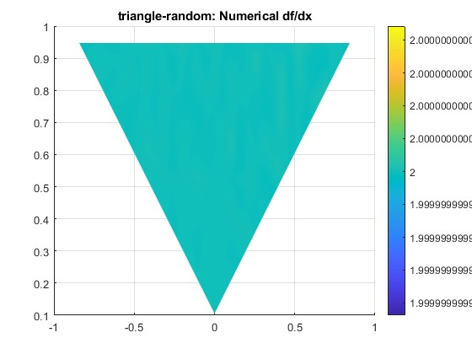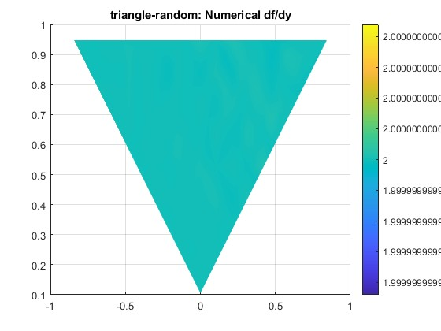

Figure Triangular geometry with non-uniform triangular elements

As shown in figure 8, although in task a this method has error, but with this f, the error is so small and could not distinguish easily. So this method also has good performance.

Above all, the order of accuracy of these discretization schemes are low, nearly 1e-14. Nearly equal to machine double precision, for the double precision, it is 1e-16, while for the single precision, which is 1e-7.

# Task 2

## a)



## b)

As shown in table 1 and figure 9 is the error of these different geometry methods. It could be see the Laplace method is second order accuracy in 1st geometry. While for other geometries, the accuracy do not change with N? so it is hard to know the accuracy.

Table Scheme accuracy

|  |  |  |  |  |
| --- | --- | --- | --- | --- |
|  | dfx | dfy | Laplace | d(dfx)+d(dfy) |
| 1st geometry | 2 | 2 | 2 | / |
| 2nd geometry | 2 | 2 | / | / |
| 3rd geometry | 2 | 2 | / | / |
| 4th geometry | 1 | 1 | / | / |

For most cases, the equation 2 method is more accurate than directly use first derivative operator two times. The reason is equation 2 include more information.

For the quadrilateral element, the equation 2 method has lower error.

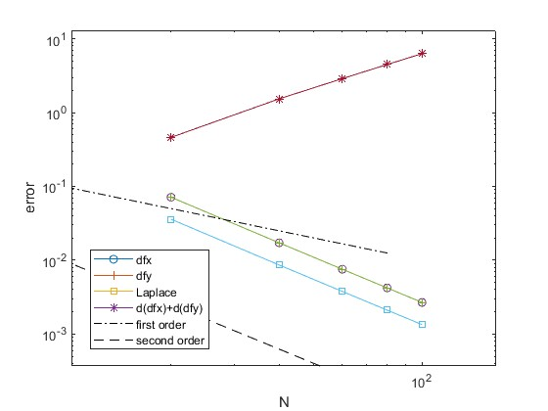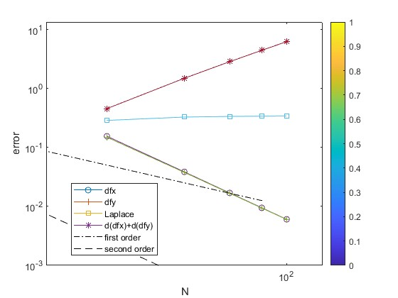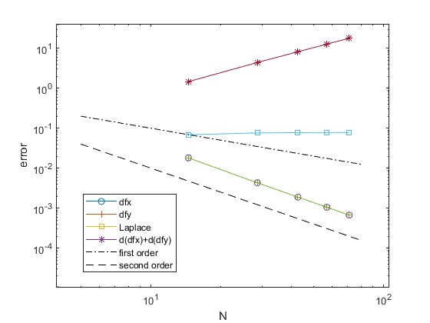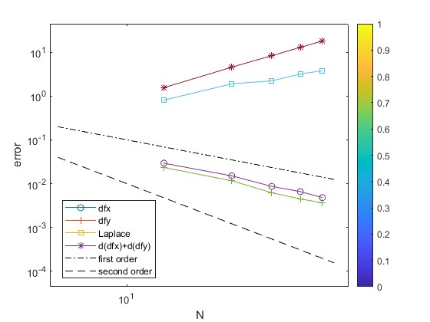

Figure Errors of these four geometries

Square geometry with quadrilateral elements (left up)

Square geometry with uniform triangular elements (right up)

Triangular geometry with uniform triangular element (left down)

Triangular geometry with non-uniform triangular elements (left down)

## c)

On a rectangular grid with smooth mapping, according to Taylor expansion, the first derivative approximation is second-order accurate. While for an arbitrary triangular grid, it is at least first-order accurate. Discretization of second derivative is inconsistent on an arbitrary grid, which could be seen in figure 9 that the accurate order is hard to define.